Random User API

👤 What Is the Random User API?
# Source: AI Source: Provided by: [Data Path: Persons Table -> ID Column: 1, Name_En Column: Motasem Essam] -> From: [ChatGPT] on [1/19/2026]
The Random User API is a free web service that generates random user data — like names, photos, email addresses, locations, phone numbers, and login credentials — for testing, mockups, or development.
It's commonly used by developers to simulate:
- User accounts
- Contact lists
- Profile cards
- Forms and tables

✅ What Random User API Can Provide
# Source: AI Source: Provided by: [Data Path: Persons Table -> ID Column: 1, Name_En Column: Motasem Essam] -> From: [ChatGPT] on [1/19/2026]
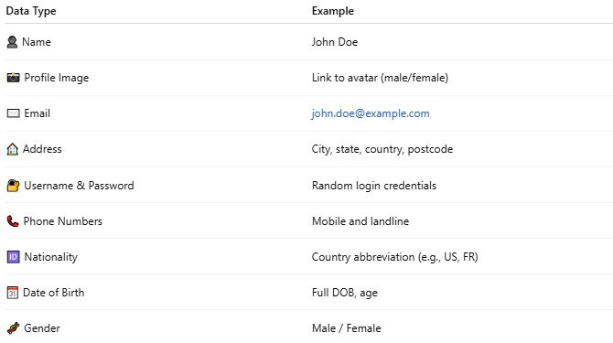

Data Type | Example
👤 Name | John Doe
📸 Profile Image | Link to avatar (male/female)
✉️ Email | john.doe@example.com
🏠 Address | City, state, country, postcode
🔐 Username & Password | Random login credentials
📞 Phone Numbers | Mobile and landline
🆔 Nationality | Country abbreviation (e.g., US, FR)
🗓️ Date of Birth | Full DOB, age
🧬 Gender | Male / Female

🔗 Base URL
# Source: AI Source: Provided by: [Data Path: Persons Table -> ID Column: 1, Name_En Column: Motasem Essam] -> From: [ChatGPT] on [1/19/2026]
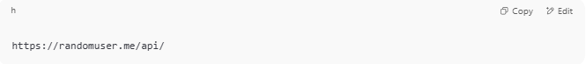
https://randomuser.me/api/

🧪 Example Request (Single User)
# Source: AI Source: Provided by: [Data Path: Persons Table -> ID Column: 1, Name_En Column: Motasem Essam] -> From: [ChatGPT] on [1/19/2026]
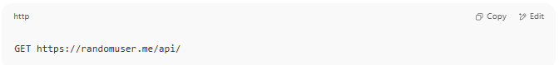
GET https://randomuser.me/api/

📤 Example Response
# Source: AI Source: Provided by: [Data Path: Persons Table -> ID Column: 1, Name_En Column: Motasem Essam] -> From: [ChatGPT] on [1/19/2026]
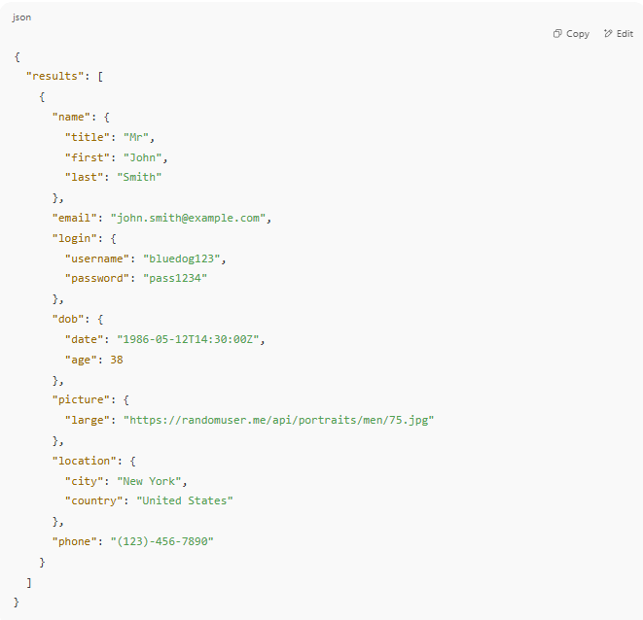
{
"results": [
{
"name": {
"title": "Mr",
"first": "John",
"last": "Smith"
},
"email": "john.smith@example.com",
"login": {
"username": "bluedog123",
"password": "pass1234"
},
"dob": {
"date": "1986-05-12T14:30:00Z",
"age": 38
},
"picture": {
"large": "https://randomuser.me/api/portraits/men/75.jpg"
},
"location": {
"city": "New York",
"country": "United States"
},
"phone": "(123)-456-7890"
}
]
}

⚙️ Useful Query Parameters
# Source: AI Source: Provided by: [Data Path: Persons Table -> ID Column: 1, Name_En Column: Motasem Essam] -> From: [ChatGPT] on [1/19/2026]
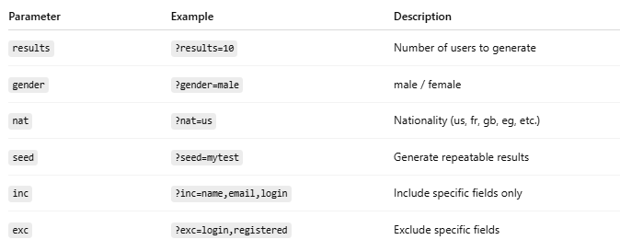

Parameter | Example | Description
results | ?results=10 | Number of users to generate
gender | ?gender=male | male / female
nat | ?nat=us | Nationality (us, fr, gb, eg, etc.)
seed | ?seed=mytest | Generate repeatable results
inc | ?inc=name,email,login | Include specific fields only
exc | ?exc=login,registered | Exclude specific fields

🧰 Use Cases
# Source: AI Source: Provided by: [Data Path: Persons Table -> ID Column: 1, Name_En Column: Motasem Essam] -> From: [ChatGPT] on [1/19/2026]
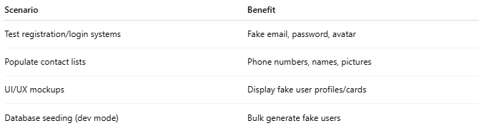

Scenario | Benefit
Test registration/login systems | Fake email, password, avatar
Populate contact lists | Phone numbers, names, pictures
UI/UX mockups | Display fake user profiles/cards
Database seeding (dev mode) | Bulk generate fake users

🧑‍💻 Sample Fetch (JavaScript)
# Source: AI Source: Provided by: [Data Path: Persons Table -> ID Column: 1, Name_En Column: Motasem Essam] -> From: [ChatGPT] on [1/19/2026]
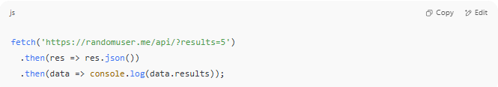
fetch('https://randomuser.me/api/?results=5')
.then(res => res.json())
.then(data => console.log(data.results));

Example
# Source: ScreenShot Source: Provided by: [Persons Table -> ID Column: 1, Name_En Column: Motasem Essam] -> Tool: [Lightshot Program] -> From [Program: Postman] on [1/19/2026]
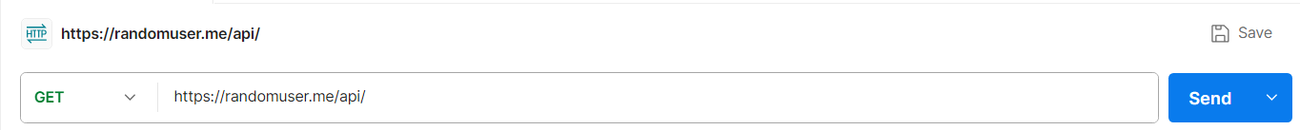https://randomuser.me/api/
